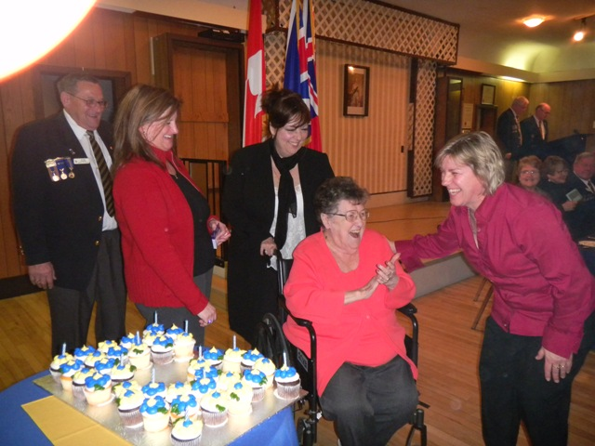
Phone: (905) 627-7221 Email: rclbr36@cogeco.net
http: //www.br36dundas.org

Marg Festing being congratulated on her 50 years membership in the Ladies Auxiliary by Stan Hicks, Past President, Terrie Gubbins, LA President, Nancy Hartmier(Marg's daughter) and Terry Kobylinski, LA 2nd Vice President.

The Bullytin
Valley City Branch 36 766 members
The Royal Canadian Legion
April – 2012

President’s Report
Our 1st Easter Egg Hunt was Egg-cellent! Thanks to the Train Club, Men’s snooker, Bev, Joan, Mary, Dorothy, Doug, Peter, Mary, Rob, Suzi and Chris Ecklund for their support! The children had a wonderful time especially those celebrating their 1st Easter. We had approximately 60 children participate. Watch for it again next year!
The Spring Work Party takes place on Sunday May 27th and we hope to see many of you. It’s light work, a great lunch is provided and many hands make it easy. Participants have been dwindling every year so we need your support. Let’s get the Branch in shape for our Veterans. Please, come out for an hour or two. We need your help; at least 40 folks are required to get the work done.
Do you have gardening skills, our good friend and comrade Ian Taylor has decided to take a well earn’d rest . Ian’s contribution to our front gardens has been tremendous over the years and will be greatly missed. If you have the time and passion for gardening please let us know.
We are in need of someone who is handy with tools, this past few years we have managed with comrades taking on individual proj-ects but we need someone who can manage the House commit-tee. Are you that person? if so, please let us know, we really could use your help.
Branch elections will be held on Wednesday, May 2nd at 8pm sharp. Come out and vote for your new executive. This is the only opportunity you have in the election of those comrades who will run your branch for the next year. If you are interested in running for office, please let us know and someone will nominate you.
As always, if you have questions or concerns please feel free to talk to me at the branch or leave me a message with the office and I will call you at home.
John Murphy - President, Branch 36

John Murphy - President

John Murphy
President

Ways & Means Report

I have to start this report with a plea for help. The
outside BBQ staff want to retire their aprons and I'm
looking for help with the BBQ's. I know that this is a
lot of work but if I can't find anyone to help then the
BBQ's won't be able to happen. PLEASE, if you can
help I would be very grateful and so would a lot of
other people. If you can help, please see me at the
branch or leave your name and phone number (or
email) with the bar staff and I will get back to you
ASAP. Please don't sit back and think that someone
else has already offered. The more help that we have the easier the workload will be. IF I can get the help that I need, the BBQ's will happen on June 17, July 22, August 19, and September 23. These dates are not set in stone because if I don't have any help, we don't have any BBQ's.

I'm also wondering if any of the members or their friends and family are interested in having another PARKING LOT SALE this spring. If you're interested in this sort of thing please leave your name and phone number (or email) at the branch and I'll get back to you.

The Fish Fry's will continue on the second Friday of the month throughout the summer, and we hope that you and your friends are able to attend.

On a closing note, remember Branch Elections are the 2nd May. Maybe things have changed in your busy schedule and you have a little more time to dedicate to the branch. If so, please consider having someone nominate you and standing for a position on the executive. If you don't have that kind of time, please remember to attend the elections and vote for the people that you would like to see running YOUR branch. If you don't vote, you shouldn't complain about the way that things are going.

Hope to see you all at the branch.

Dawn Lewis - Ways & Means Chair, 2nd Vice President

Dawn Lewis
2nd Vice President &
Ways & Means Chair
Bursaries Report

Royal Canadian Legion Bursary Program - $500.00 Maximun Each Academic / Scholastic Year
The Bursary Program is designed to assist those students who enter a post secondary school of education (including courses and training programs of a technical and vocational nature) and pursue the same course throughout their academic years.

To be eligible for bursary funds, the student must be enrolled in a post secondary school and be a war veteran, or the child or grandchild of a war veteran, or be an Ordinary or Life Member of a branch of The Royal Canadian Legion, or the child or grandchild of an Ordinary or Life Member of a branch of The Royal Canadian Legion, or be an Associate Member of a branch of The Royal Canadian Legion, or the child of an Associate Member of a branch of The Royal Canadian Legion, or be a member of the Ladies' Auxiliary of a branch of The Royal Canadian Legion, or the child or grandchild of a member of the Ladies' Auxiliary of a branch of The Royal Canadian Legion.

The Ontario command office must receive a complete application from students who are currently attending Post Secondary Education by the last Friday of March in any scholastic year.

The maximum award to a student in each Academic/Scholastic year (September 1 to August 31 of the following year) will be $500, but the District Selection Committee may recommend a lesser amount. The committee will, in all cases recommend a dollar value for each bursary to be awarded. The decision of the District Committee is final.

I will have new forms for the 2013 school year in the fall – August/September. They will be available in the Branch.

For more details and an application form please visit our Branch or speak with me.

Mike Alkerton - Past President and Membership Chair

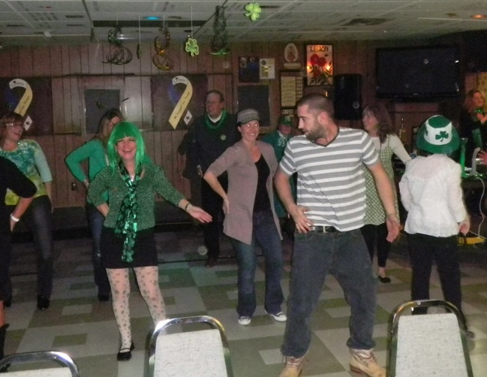
Colour Party Report

On Saturday March 3rd, 7 members of the Colour
Party attended the Honours and Awards Banquet
and were proud to present the colours during the
celebration.

At the General Meeting that took place on March 20th,
6 members of the Colour Party attended and took
part in the ceremonies. As always we welcome any-
one who would be interested in joining the Colour
Party and assistance will be given to anyone requiring
a uniform.

James Byron - Colour Party Commander - 905-578-2758

James Byron
Colour Party
Commander
&
Sergeant at Arms

St.Patrick’s Day Dance a Success
Sunday - 27th May - Spring Work Party - 9:00am Volunteer some time to help spruce up the Branch for our D-Day Church Parade. Both inside and outside tasks are available - Add your name to the sign-up sheet next to the side entrance doorway.

Brody Howlett gets tips on Irish Dancing from a Leprechaun at the St.Patrick’s Day Dance.

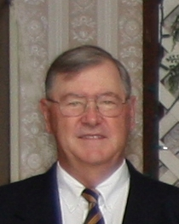Gord Sharpe
Special Events Chair

Membership Report

Not much to report this month. Thanks to those
who brought in new members.

Welcome to the Branch !

We still have about forty members who have not
renewed.

Please drop by or mail in your 2012 dues - $50.00. We will drop below 800 members for the first time. This is not good.

As always if you have any concerns or questions please contact me.

Mike Alkerton - Membership Chair

Special Events Report

On Sunday, 3rd June, 2012 we will be having our
annual church parade. All those wishing to take part
please fall in at the Branch at 09:45am.

Everyone is welcome to join the formation as we
make our way to St. James Anglican church.

We will march off at 10:15am and proceed to
St.James church on Melville Street.

For those who cannot march in the parade, but wish to attend the church service, it will start at 10:30am and all are welcome to attend.

Lunch will be available at the Legion after the service

Gord Sharpe - Special Events Chair

Gord Sharpe
Special Events
Chair

Mike Alkerton
Membership
Chair
Ladies Auxiliary Report

The Ladies Auxiliary has been very busy these past
few months with hosting many sporting events. This
is good for our LA as well as for the branch. We
hosted the District Team Dart Tournament on Saturday
April 14th. This brought 128 dart players from all
around to our legion and we gave them a warm
welcome. On April 28th Terry Kobylinski and Terrie
Gubbins will be attending the Provincial Singles and
Doubles Dart Tournament in Aurora. Good luck to all
who are playing in these sporting events.

On April 22nd we hosted the LA Zone Convention which brought many comrades from other LA's to our branch.

Back on March the 3rd we celebrated our 67th Birthday in conj -unction with the branch Honours and Awards. At this event we handed out the following service pins: Marg Festing 50 years,
Shirley Arnold 40 years and Marion Hunt 15 years. The following people were unable to attend but will be receiving their pin in the near future: Ruth Rivers 55 years and Arleen Gross 35 years. Congratulations to all and thank you for your continued support.

The Beef on a Bun, Lasagna roll-up nights have been consistent and going well. The final nights for this season will be Friday April 27th and Friday May 25th. Please come out and enjoy a great meal and help support the Branch all at the same time. Watch for notices around the legion and in your email as May just might bring a surprise.

The LA is always looking for new members. If you or anybody you know is interested please don't hesitate to contact me.

Yours in Comradeship,

Terrie Gubbins - President - Ladies Auxiliary

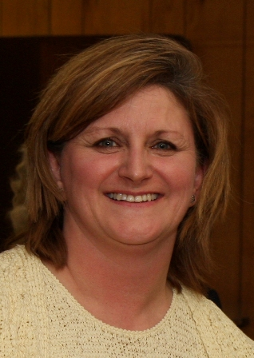Terrie Gubbins
Ladies Auxiliary
President
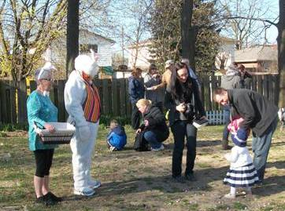
Easter Bunny observes Branch 36 Easter Egg Hunt
Banquet Hall Report

The Banquet Hall is available for rental. The Wentworth Room downstairs is available for use on a first come, first served basis.

It will accommodate from 5-65 people. It is used for memorial services, meetings, birthdays, retirement parties, and any other party you can think of. Just call the office to book the room:
(905) 627-7221. There is no charge.
For more information call the Legion office at 905-627-7221.
All people have the right to stupidity but some abuse the privilege

As long as there are tests, there will be prayer in schools.

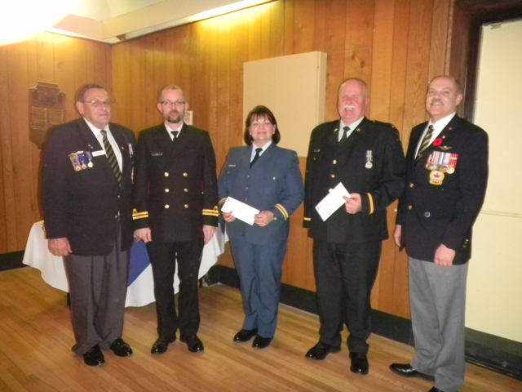
House Report

This year’s Spring Clean Up Party will be held on Sunday, 27th May, 2012 starting at 9.00am. Volunteer some time to help spruce up the Branch in time for the D-Day Church Parade to be held on the following Sunday 3rd June, 2011. There will be a sign-up sheet posted on the Events Bulletin board.

Lunch will be provided to all the volunteers. It is only a couple of hours of light work and a great lunch.
2012 Honours and Awards Recipient
Lieutenant Derek Evans representing RCSCC Dundas Sea Cadets, Captain Michelle Allard representing 735 Firebird Air Cadet Squadron and 2nd Lieutenant Al Smethurst representing #2685 Royal Canadian Army Cadets accept contributions to their cadet organizations from Branch 36, represented by Stan Hicks, Sick and Last Post Chair at left, and Rick Valois, Veterans Services Chair Br. 36 at right.

Last Post
Anna White - January 25th, 2012
John Neale - February 10th, 2012
George Kay - February 21st, 2012
Shirley Laufman - March 2nd, 2012
Virginia Lawrence - April 1st, 2012

We Will Remember Them

Sick Report

February - 2012
2nd - Trevor Meldrum out and about
2nd - Stan Rankine out and about
5th - Bonnie Patro at Juravinski
5th - Virginia Lawrence at St.Joe’s
9th - Jim Lewis at St.Joe’s - in and out
10th - Rene Slote at St.Joe’s - pneumonia
15th - Bonnie Patro at home
17th - George Kay
29th - Rene Slote at home

January - 2012
17th - Ann White at St.Pete’s
17th - Jim Lewis at the Juravinski
17th - Doug Wood at home after Bypass
18th - John Toomey at Shalom
18th - Jim Lewis at Juravinski - congestive heart
20th - John Neale at General
23rd - visited John Neale at General
23rd - visited Ken Harrison at General - coming home this week
23rd - visited Stan Rankine at St.Joes - coming home this week
27th - Jim Lewis at home
27th - Ken Harrison at home
27th - Stan Rankine at home

March - 2012
3rd - Gerry Hopkins at General - low blood
6th - Jim Layne at General - Bypass
6th - Gerry Hopkins at home
9th - Gerry Hopkins feeling better - going for tests Mar.12th
9th - Kirk Hopkins feeling better after shoulder surgery
9th - Virginia Lawrence - out of ICU at St.Joe’s
30th - Ernie Bodden waiting for surgery on knee or hip

April - 2012
1st - Edna Hall at General – broken arm
1st - Jim Lewis at St.Joseph’s

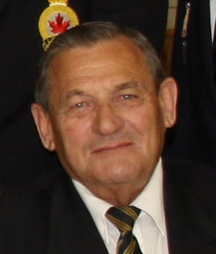Stan Hicks
Sick / Last Post
Chair
Honours and Awards Report

The 2012 Honours and Awards and Ladies Auxiliary
Banquet was well attended. Service pins and
certifIcates of appreciation were handed out to valued
branch members. Contributions were also given to
local cadet groups representatives. We also named
our Legionnaire of the year - George Martin.
Charlie Parsons - Honours & Awards Chair

Public Relations Report

The Legion is a democratic organization and each year we have an election to vote for the executive to run our Branch. Our election is at 7:30pm on Wednesday, 2nd May, 2012. Any Branch 36 Legion member is eligible to run for a position, and all Branch 36 members can vote in the election. If you are interested in helping to run the Branch, or you want to vote for someone in a position on the executive come on out and vote.

Only with the participation of the membership can the Legion stay healthy. You may not be able to get to the Branch on election night, but it doesn’t mean you can’t take part. Let John Murphy the current Branch President know about your interest to take part, and I am sure he will present it at the election.

You may not wish to be on the Executive, but there are lots of appointed positions for those wishing to take part in helping to run the Branch, so you may not want to be President, but you can still take part - come on out and let the current executive know of your interest.

Peter Whittaker – Public Relations Officer

I wondered why the frisbee was getting bigger… then it hit me.

You know you’re stupid when you wake someone up by asking if they’re asleep.

House Report

Picture description here

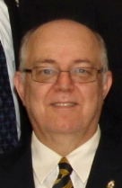Charlie Parsons
Honours & Awards
Chair

Youth Education Report

The 2011 Remembrance Programme continues
to gain rewards and recognition. The following
students were recognized for their excellence at
the Zone level.

First Place
Max Schwartz - Westdale - Senior Poetry
Namita Kalra - Westdale - Senior Essays
Virginia Wolfe - Rehoboth - Intermediate Essays
Lily Jiang - Westmount - Senior Colour Poster
Srinidhi Shaw - Dalewood - Intermediate Colour Poster

Second Place
Sarah Pennings - Rehoboth - Intermediate Poetry
Daniel Liu - Dalewood - Intermediate Black and White Poster

All of the First Place winners named above advanced to District competition, where they earned further recognition, but unfortunately, no gold medals. Next year, we hope.

Congratulations to the successful entrants. Thank you to the two-hundred plus entrants and their teachers. Thank you to the Branch for their support.

Respectfully submitted,

Lorne Evans - Youth Education Chair

Lorne Evans
Youth Education
Chair

Perennial Plant Propagation Party -
Saturday, May 26, 2012 - 11am to 1pm
If you are dividing or thinning any of your perennial plants, whether sun or shade loving, please bring these divisions to the Branch to help us spruce up our gardens. Just put them in a labelled pot or bag and we will ensure they have many more years of life in our gardens. You can also come out on this day and help with the planting! Hope to see you then!


Canteen Report

Things have been going quite well in the canteen due to
the winter that never happened. Now as spring and
summer approach we hope that you will still be able to
make time to stop by the Branch for a cold one and meet
up with some of the other members. Remember that you
can always bring your friends and neighbours with you.
Our branch remains strong because of you, the members,
bringing in your friends and neighbours and inviting them to also become members. Without you we wouldn't be able to do the things that we do both in the Branch and in the community.

Dawn Lewis - Canteen Chair and 2nd Vice President

Poppy Fund Report

Due to a successful Poppy campaign last November,
the Poppy Fund was able to donate monies at the
Honours and Awards banquet held on March 3rd. A
$15,000 cheque was presented to Maureen Ellis of
St. Joseph’s Villa, and another $15,000 cheque was
presented to Roger Ali of the Juravinski Cancer
Centre. Once again, a great big thank you to all of
our volunteers who were out last year distributing
Poppies. Without you, donations to these establishments would not be possible.

Gerry Belec & Cheri Harrington - Poppy Co-Chairs

Gerry Belec
Poppy Fund
Chair
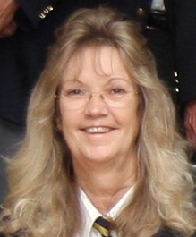Dawn Lewis Canteen Chair

Sports Report

On March 10th Branch 551 Waterdown held the
Zone Euchre tournament. One of our teams made
up of Len Owen, Ivan Mclean, Bettina Slaght and
Marv Rioux qualified for District which was held on
March 31st at Branch 136 Milton.

On March 18th Branch 36 Dundas hosted the darts
mixed teams tournament and on March 24th we
also held the mixed zone doubles. One team made
it on to Districts which will be held on May 12th at
Branch 15 Brampton.

On March 24th Branch 120 Georgetown hosted the
District Youth Darts and Branch 36 players placed
as follows: Junior Teams: Matt Flahery, Rhyleigh
Hopkins, Lexie Revil and Kieran Davis - 2nd place.
Senior Singles: Rachel Harrington - 2nd place.
Senior Doubles: A.J.Lewis and Travis Hopkins -2nd place.
Senior Teams: Mitchell Purchase, Rachel Harrington, A.J.Lewis and Curtis Holme - 2nd place.
Members of the Branch 36 Youth Darts will be playing in the Provincial Youth Darts Tournament at Branch 258 Highland Creek, 45 Lawson Road Scarborough, on 12th May, 2012.

You can still sign up for the following Legion Sports Events:
District B – Regular and Senior Horseshoes – Branch 197 – Acton – Saturday, 23rd June, 2012
15 Wright Street, Acton, Ontario
Registration - 8:15am-9:15am
Play commences at 9:30am sharp
Entries: No limit from Zones - singles and / or 2 person teams

District B – Regular and Senior Golf – Branch 463 – South Brant – Saturday, 14th July, 2012
Pelham Hills Golf Course, 196 Webber Road, Welland, Ontario
Registration – 6:45am-7:45am
Shotgun start at 8:00am
Entries: 14 - 2-person teams per Zone

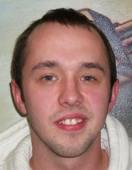
Jordan Deneau
&
Brody Howlett
Sports
Co-Chairs


Branch 36 - Upcoming Events

May 2012 Events
President's Meat Draw - 5th, 12th, 19th May - 3-4pm
Weekly Meat Draw - Every Saturday - 4:30pm
Wednesday - 2nd - Annual Branch Elections – 8:00pm
Come out and elect your Branch Executive
Tuesday - 8th - Branch Colour Party Meeting -7:00pm
Tuesday - 8th – L.A. Monthly Meeting - 7:00pm
Friday - 11th - Fish Fry - 4:30-7:00pm
Tuesday - 15th - Branch Monthly Meeting – 7:30pm
Monday - 21st - Victoria Day - CLOSED
Friday - 25th - Beef on a Bun - 5:30-7:30pm
Saturday - 26th - Plant Propagation Day - 11:00-1:00pm
Bring in your spare perennial plants and they will be used to help beautify the Branch property
Sunday - 27th - Spring Work Party - 09:00am
Come out and help clean up the Branch
Both inside and outside tasks to be done
Your help makes the Branch what it is today

June 2012 Events
Weekly Meat Draw - Every Saturday - 4:30pm
Sunday - 3rd - Br.36 D-Day Church Parade - 09:30am
Friday - 8th - Fish Fry - 4:30-7:00pm
Tuesday - 12th - Ladies Auxiliary Monthly Meeting - 7:00pm
Thursday - 14th - Summer Mixed Darts Registration - 8:00pm
Tuesday - 19th - Branch Monthly Meeting – 7:30pm

July 2012
Weekly Meat Draw - Every Saturday - 4:30pm
Sunday - 1st - CANADA DAY - Bar 12 noon-5pm and
Good Neighbour BBQ from 2pm to 5pm
Monday - 2nd - CLOSED
Friday - 13th - Fish Fry - 4:30-7:00pm

August 2012
Weekly Meat Draw - Every Saturday - 4:30pm
Monday - 6th - Statutory Holiday - CLOSED
Friday - 10th - Fish Fry - 4:30-7:00pm

