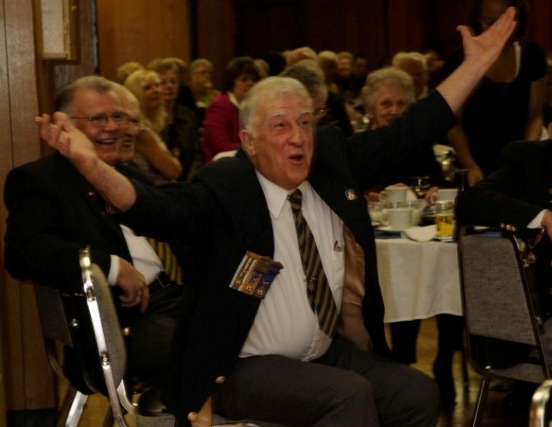
The Bullytin
Valley City Branch 36
The Royal Canadian Legion
April – 2010
Phone: (905) 627-7221 Email: rclbr36@cogeco.net
http: //www.br36dundas.org
Mike Alkerton, Past President Branch 36, reacts to the
announcement of his award of the Meritorious Service
Medal at the recent Honours and Awards Banquet.

President’s Report

Winter is over and we cannot complain about the
weather. The Branch has done well with the
membership supporting all of our activities
including Fish Fry’s, Beef on the Bun and our
Turkey Roll.

The general meeting was held on March 17th, attendance could have been better. This was your opportunity to express your opinion on how your Executive are running your Branch. Remember decisions are made at these meetings not in the club room. We did welcome 24 new members to the Branch. Say hello when you next see our new members in the club room.

The Branch elections will be held on Wednesday May 5th at 8.00pm sharp. Come out and vote for your new Executive. If you are interested in running for office let us know and someone will nominate you.

If you have any questions or concerns please feel free to talk to me, another member of the executive, or leave me a message at the office and I will be happy to call you and address them.

Our Church Parade will be Sunday, 6th June, 2010. Please check the notice board in the club room for assembly details.

We are still in need of a volunteer who has some building skills to champion the House Committee for inside projects. If you can spare a few hours a week and can help please let us know. This is a very rewarding position and you will have lots of help.

John Murphy

John Murphy
President

Ways & Means Report

Welcome to a new season at Branch 36. Winter sports and events are winding down and plans are being made for the summer months. We hope that you will consider joining us at the Branch for some (or all) of them.

The Fish fry's will continue all summer long on the second Friday of each month and the Family BBQ's are back as well. The first one is on Father's Day, Sunday June 20th. What a great way to tell the Dad's out there that you love them. Treat them to a delicious dinner. The Branch opens at 2:30 so that you are able to enjoy a chilled beverage before dinner. The actual dinner will be served from 4pm until 6pm. The meal consists of steak (cooked to order), chicken, or hamburgers, with potatoes, salads, fried onions, rolls, and all of the fixing’s including sour crème, pickles, olives, tomatoes, etc. We are really looking forward to seeing you and your family and friends at these events.

We are also planning our Spring Parking Lot/Trunk Sale. So when you do your Spring Cleaning and/or de-cluttering your house, consider setting the items you no longer want, or need aside, and renting a space in the parking lot to sell these things and make a few bucks (the Branch will also be accepting donations for the Legion table if you prefer).

House Report




John Murphy
House Chair

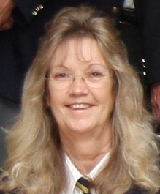
Dawn Lewis
1st Vice Pres
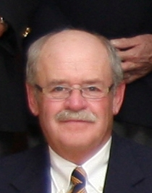
Al Blackburn
3rd Vice Pres
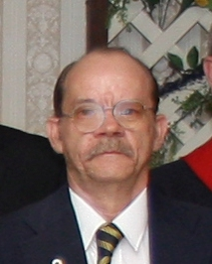
Wayne McKay
Committee Member
Your Ways & Means Committee

Ways and Means Report continued

The date has been set for Saturday June 5th. Watch the Blue Books, the White Board, or check the Website for more details.

As well, don't forget that Branch elections are being held on May 5th, at 8pm. Bring your membership card and have your say on who you would like to see running for the Executive, that runs YOUR Branch. Remember these are the people that volunteer to work for YOU. Maybe you might even be interested in becoming an executive member.

Once again, thank you all for your support in all of the events that we hold at the Branch for you, the members. Without you none of this would be possible. Thank You.

Dawn Lewis – Ways & Means Chair

Special Events Report

On Sunday, 6th June, 2010 we will be having our
annual church parade. All those wishing to take
part please fall in at the Branch at 09:45am.

We will march off at 10:00am and proceed to
St. James church on Melville Street.

For those who cannot march in the parade but wish to attend the church service, it will start at 10:30am and all are welcome to attend.

Gord Sharpe

Gord Sharpe
Special Events Chair

Colour Party Report

The Colour Party had the chance to present the
colours at the Honours & Awards Dinner on 6th
March - where Suzi Mellen, Greg Sherring and
Chris Slote were presented with Certificates of
Appreciation.

Dorothy Foord was presented with an award for long service to the Colour Party.

On 17th March at the General Meeting we again presented the colours. As always we have openings in the Colour Party for new members.

If interested please contact:
James Byron (Colour Party Commander) 905-578-2758

James Byron
Colour Party
Commander

House Report

As spring is upon us, we are starting to look out-
side, and with this in mind it is RECRUITMENT
TIME once again for volunteers for our SPRING CLEANUP.

The cleanup will be on Sunday May 30th at 8.30am
and if you can spare a couple of hours to help get
the Branch ready for the Church Parade add your name to the sign up on the sheet located on the wall beside the office. Just bring a friend, a rake or a broom along with your appetite.
Just remember "Many hands make light work".

Hal Hamilton “Counting on Your support”

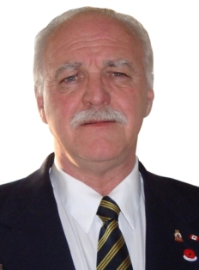
Hal Hamilton
House Chair

Membership Report

Membership
Thank you for your renewals. We are on track to be close to last year’s numbers. We are always recruiting new membership so “Just bring one”.
If we do not have your e-mail address we would like to have it. It will be used only for Branch 36 reports. As always, any questions please contact me.
Mike Alkerton

Bursary
If grandchildren or children of Ordinary or Associate members are in post secondary school they may be eligible for a Bursary from the Legion. Please contact me if you have questions.

Mike Alkerton

Mike Alkerton

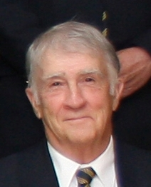
Mike Alkerton
Membership
Chair

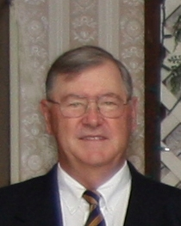Gord Sharpe
Special Events Chair






Poppy Fund Report

At the recent Honours and Awards Banquet we
were able to make the following donations for
the Branch from the Poppy Fund.

Maureen Ellis from St.Joseph’s Villa accepted a
cheque for $10,000 for the St.Joseph’s Villa
Veterans.

Parker Neal from McMaster University Medical Centre accepted a cheque for $10,000 for MUMC Hospital’s Childrens Cancer Research.
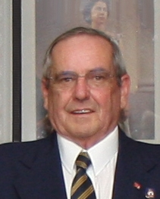
Gerry Belec
Poppy Fund
Chair

Post Euchre Practice Party

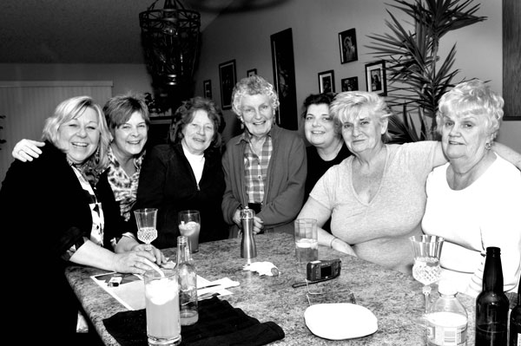

Marianne Jansink, Sally Lennard, Maggie Mulder, Edna Hall, Fay Pearlman, Joan Chontos and Bonnie Patro all met at Joan's house to practice Euchre for the Zone Euchre Tournament held at the Branch on 20th February, 2010.

Branch 36 - Upcoming Events Calendar

Weekly Meat Draw - Every Saturday - 4:30pm

May 2010 Events
Wednesday – 5th May - Annual Branch Elections - 8pm
Friday – 14th May - Fish Fry - 4:30-7:00pm
Saturday – 22nd May - Perennial Plant Day - 11am-1pm
Friday – 28th May - Beef on a Bun - 5:30pm-7-30pm
Saturday – 30th May - Spring Work Party - 09:00am

June 2010 Events
Sunday - 6th June - Branch 36 D-day Church Parade
09:45am - Fall in at Branch
10:00am - March Off
10:30am - Church Service at St.James Church Melville Street
All Legion members are welcome to attend service
Friday -11th June - Fish Fry - 4:30-7:00pm
Sunday - 20th June Branch open 2pm - Family BBQ - 4-6pm

July 2010 Events
Friday –Thursday - 1st July - Canada Day – 2-5pm
Good Neighbor BBQ - Hot Dogs and Burgers for neighbors
of Royal Canadian Legion Valley City Branch 36
9th July - Fish Fry - 4:30-7:00pm
Sunday - 18th July Branch open 2pm - Family BBQ - 4-6pm

August 2010 Events
Friday - 13th August - Fish Fry - 4:30-7:00pm
Sunday - 22nd August Branch open 2pm Family BBQ 4-6pm

Invite friends and relatives to Legion events

Ladies Auxiliary Report

The upcoming beef on a bun nights will be held
on Friday April 23rd and Friday May 28th.
These are the last two for this season. We would
like to take this opportunity to thank all of our
customers, supporters and helpers. We couldn't
accomplish it without you.

Our Birthday Banquet/Branch Honours and
Awards was a complete success. We would like
to congratulate the following recipients of service pins and certificates:
Service Pins
Kay Southall - 50 year pin - Way to go Kay
Anne Hayes - 35 year pin
Jean Miller - 35 year pin
Debbie Cooley - 30 year pin
Terry Kobylinski - 15 year pin
Terrie Gubbins - 15 year pin
Sue Skelpowicz - 10 year pin
Certificates of Merit
Terry Kobylinski
Terrie Gubbins
Certificates of Appreciation
Gerry Hopkins, Sue Sklepowicz, Dana Dilabbio, Debbie Cooley, Pat Raynsford, Lorrie Deneau, Suzi Mellen and Marie Kobylinski.

Congratulations to all and thank you for all of your time and efforts to ensure our organization is a success.

The LA Singles and Doubles Provincial Darts is being held in Pickering on Saturday April 24th. Sue Sklepowicz is partic-

Terrie Gubbins
President
Ladies Auxiliary

pating in the singles and the teams of Sue Sklepowicz and Dana Dilabbio as well as Terry Kobylinski and Terrie Gubbins are participating in the doubles. On April the 10th the LA Team District Dart tournment is being held in Waterdown. The teams of Debbie Cooley, Lorrie Deneau, Pat Raynsford and Marie Kobylinski as well as Terry Kobylinski, Sue Skelpowicz, Dana Dilabbio and Terrie Gubbins will be attending. Good luck to everyone in both tournaments.

If you know of anyone that is interested in joining the LA please ask them to talk to one of our comrades with any questions so that we can educate future members on our organization.

Yours in Comradeship,

Terrie Gubbins – Ladies Auxiliary Chair

Attention Gardeners! - Perennial Plant Recycling Day

Are you dividing or pulling out any perennials this spring?
We could reuse them here at the Branch, just drop them off at the Branch between the 11am and 1pm on Saturday, 22nd May, 2010.

We will recycle your perennials and help beautify the property. They will be placed in our horseshoe pits area, and along the outside of the fence on the Peel Street entrance to the Branch. You will be able to see your plants grow again.

You could also stay afterwards for the Presidential Meat Draw at 3pm as this will be the last Presidential Meat Draw until next fall. Thank you.

Suzi Mellen
Sick Report - Stan Hicks

January 2010
13 - Marv Turpin at home
14 - Jim McHugh at home
15 - Chuck Clarkson at MacuHughHuHHHHHH

February - 2010
1 - Chuck Clarkson at home
1 - Dick Howarth - out and about
4 - Marg Mulder at General
11 - Marg Mulder at home
11 - Austin McManamy moved to St.Joe’s villa
12 - Jim McHugh - out and about
13 - Murray Floyd at Mac for tests
18 - Bob Jennings at General for tests
19 - Murray Floyd still having tests
22 - Ed Graham at General
24 - Howard Wilson at Mac
March 2010
4 - Bob Jennings at home
4 - John DeWilde at home
8 - Bev Hudson at General
15 - Bruce Delottinville
15 - Bev Hudson at home
30 - Marv Turpin at St.Joes

Last Post

Bill Place – 23rd January, 2010
Fred Kraav – 11th February, 2010
Ed Grahams – 5th March, 2010
Don Clark – 15th March, 2010
Kelly Arnold – 25th March, 2010

We Will Remember Them

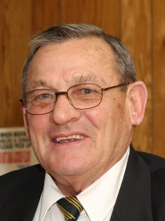
Stan Hicks
Sick / Last Post Chair

Marie Kobylinski - Legionnaire of the Year – 2010

Banquet Hall Report
Hello fellow comrades, I would like to take this time to remind you that the Banquet Hall and Wentworth room are always available. The Banquet Hall can be booked with a deposit for any event you need to plan and the cost is always friendly to your wallet. The Wentworth Room is also available free of charge to anyone.
All bookings can be made by calling the Legion office at 905-627-7221. Should you need your event to be catered, our chef can make a great meal for a great price and will leave you satisfied and smiling.
Kristen Blair - Banquet Hall Chair

Marie Kobylinski is presented with the Legionnaire of the Year award by John Murphy President of Branch 36, and given control of the remote for the TV in the club room by last year’s Legionnaire of the year Jim Sherring.

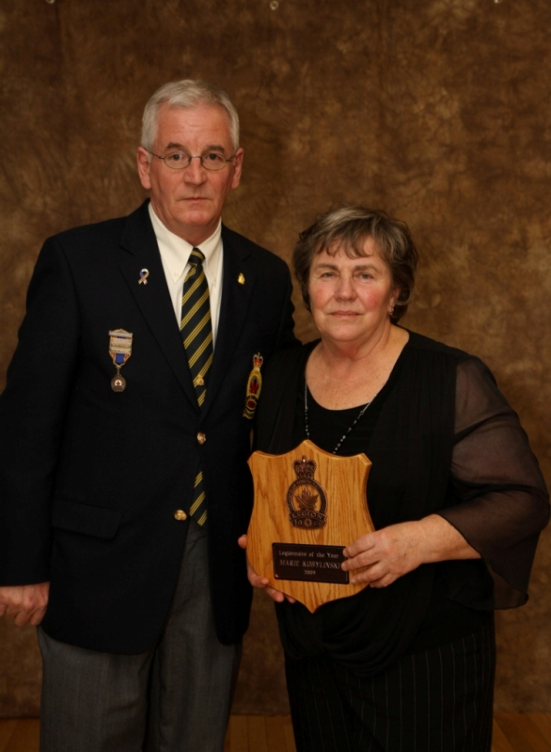

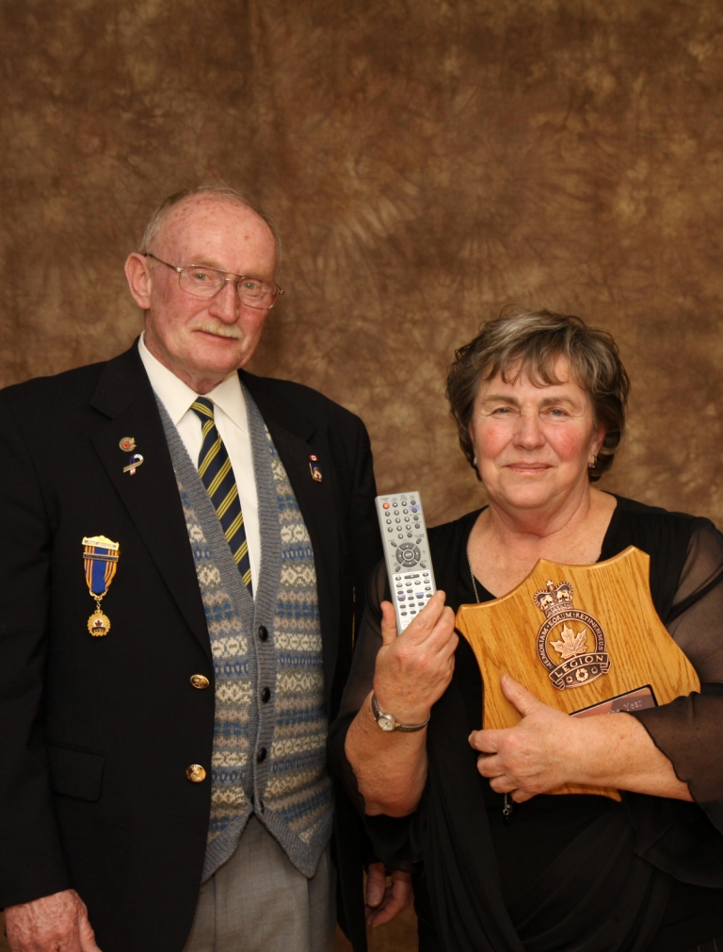
Honours and Awards Report

With thanks to all attendees, the annual Honours
and Awards and Ladies Auxiliary 65th Birthday
Banquet was an unprecedented success.

Congratulations to:

Marie Kobylinski - 2009 Legionnaire of the Year

Congratulations to:
Al Magson and Paul Penney, who were awarded Lifetime Legion Memberships
Congratulations to:
Mike Alkerton who was awarded the Meritorious Service Medal
and to all of the other recipients of pins and certificates.

An album of photographs of the event is available in the Branch for you to enjoy.

Next year’s event will be on 5th March, 2011. The sooner you become a member, the sooner you will have your 5 year membership pin.

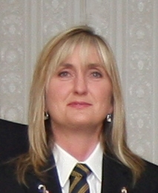
Suzi Mellen
Honours and Awards
Chair






Sports Report

Congratulations to two of our mixed dart teams
that qualified to play at District in May, and our
euchre team that won Zone and will be playing
at District in April.
I would like to form a Sports Committee. If you are interested in joining me on this committee please come and see me.
There are still some events on the sports board so take a look and sign up.
Yours in Sports
Len Owen

Len Owen
Sports Chair

Do you have any Canadian Tire Money?

We continue to collect Canadian Tire Money at the Branch to use for the purchase of gardening material. There is a collection box near the information board. Your donations are appreciated. If you don’t have any Canadian Tire Money, why not drop in some coins?

Thank you - Suzi Mellen

Excavating
Dump Trucks Pipeline Contractor

24hr Emergency Services
905-628-4148 www.ronleeconstruction.ca

If you have access to a computer with internet access you can view this Bullytin online at the following link:

http://www.br36dundas.org/bullytin/bullytin.htm/1005.doc

Youth Education Report
I am very pleased to report that, in the
second year of the Youth Education
programme's re-introduction, a number of
Branch 36 Valley City Legion student partic-
ipants in our Remembrance poster, poetry,
and essay competitions, as well as in Public
Speaking, have won further honours at the
Zone level, and beyond! They are as follows:

Remembrance Colour Poster: Senior - Bronze Medal (Zone)

Remembrance Poetry: Junior – Bronze Medal (Zone)
Intermediate - Silver (Zone)
Senior - Silver (Zone)

Essay: Intermediate – Silver (Zone)
Senior – Gold (District) - Advancing to Provincial

Public Speaking: Senior - Gold (Zone) - Advancing to
District

A great deal of appreciation has been expressed by teachers,
parents, principals and students regarding the Branch’s support and generosity towards local youth.

I hope to continue to build on this year’s successes.

Lorne Evans
Youth Education
Chair



