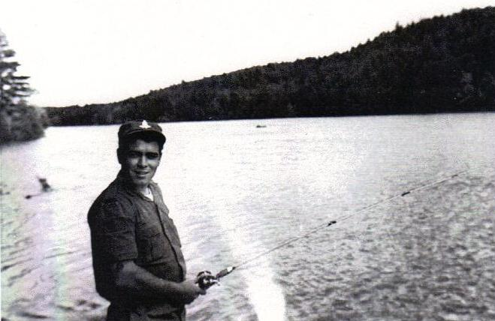
Phone: (905) 627-7221 Email: rclbr36@cogeco.net
http: //www.br36dundas.org

Do you recognize this Branch 36 veteran? He served with the Royal Canadian Horse Artillery, and is seen here taking a well deserved time out during Brigade War Games at C.F.B. Petawawa in 1959. See page 4 for answer.

The Bullytin
Valley City Branch 36 - 862 Members
The Royal Canadian Legion
April – 2011

President’s Report

At long last the winter is almost over and spring is on the
way (we hope). It has been a busy time at the branch with
the Fish Fry nights and the Ladies Auxiliary’s Beef on a Bun
having had great success and they continue to grow. We
started a new feature on Fish Fry nights called “Open Mike
Night” run by Chris and Rob Turner. If you can play an
instrument or sing, why not come out and have some fun?
The general meeting which was held in March was well attended. This is the perfect opportunity for members to air their views and be involved in the voting process when required.
Branch elections will be held on Wednesday, May 4th at 8pm sharp. Come out and vote for your new executive.
If you are interested in running for office, please let us know and someone will nominate you.
We continue to have more and more members give us their email addresses. This is an excellent way for us to communicate with the membership and keep you informed of the events that are going on at the Branch.
If you have not given us your email address yet, why not, we promise not to give your information to any outside source. It will be used for Branch 36 communications only .
If you have any questions or concerns please feel free to speak to me in the Branch or leave a message in the office, and I will be happy to call you and address them.

John Murphy - President

John Murphy
President
Correction: Apologies to Rod Gallant and Greg Paterson for the misspelling of their names in the February issue of the Bullytin.

Ways & Means Report

A BIG Thank You to everyone that supports our Fish Fry's on the 2nd Friday of every month. Please remember that this event
continues all through the summer. This is the biggest and
best Fish Fry around.

Please remember that if for any reason you’re not happy
with your meal, you need to speak up. If there’s a problem
and we are not told about it we can't fix it. You can tell me
or any of the fish fry crew and we will do our best to make
sure your next meal meets your expectations.

Good news travels fast, but bad news travels even faster.

The Family BBQ's will be starting up again in June, with the first one as usual on Father's Day. Bring Dad and the rest of the family and enjoy a great steak, chicken, or hamburg dinner with all of the fixin's. We will be cooking from 4pm until 6pm and the bar will be open at 2pm to allow you some time to enjoy a chilled beverage before dinner.

The remaining BBQ's will be on July 17, August 21, and September 18 to wrap up the season. We look forward to seeing you and your family and friends at the Branch throughout the summer.

Remember to put your loonie in an envelope with your name on it and drop it in the box next to the bar for the Weekly Meat draw. This draw continues all through the summer. If you don't think you'll be at the Branch on Saturday afternoon, please include your phone number so that we can let you know that you have won.

Dawn Lewis - 1st Vice President and Ways and Means Chair

Dawn Lewis
1st Vice President &
Ways & Means Chair
Banquet Hall Report
The Banquet Hall has lots of dates available, and it can be booked for any event you need to plan, and the cost is always friendly to your wallet. The Wentworth Room is also available free of charge to anyone. For more information call the Legion office at 905-627-7221.

Age doesn't always bring wisdom. Sometimes age comes alone.

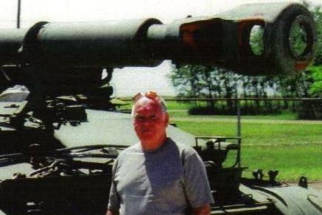
Life Members awarded at Banquet

Identify the Legion Member - Answer

If you guessed Art Alkerton you were correct. He is pictured above on a visit to C.F.B. Shilo in Manitoba. Not often seen around the Branch, this 48 year member is Mike Alkerton’s brother. If you see him in the Branch tell his brother Mike.

Marilyn Latchford and Dawn Lewis with Legion Life Member awards presented to them at the 2011 Honours and Awards Banquet.
Colour Party Report

The Colour Party took part in the Honours and Awards
Dinner that took place on 5th March. On 16th March we
paraded the colours for the Bi-Annual General Meeting.
As always, we were there to parade the colours and
initiate new members into the Legion.

We are looking forward to the Church Parade taking
place in June and as always we have openings in the
Colour Party for new members. If interested please
contact:

James Byron - Colour Party commander - 905-578-2758

James Byron
Colour Party
Commander
&
Sergeant at Arms

Bursaries

Bursaries are made available by the Royal Canadian Legion to assist in children’s education. If you are interested in this please see me in September. Thank you.

Mike Alkerton - Bursaries Chair

Snooker Tournament Food a great success ! ! !

In March the Branch hosted a Legion snooker tournament and the volunteers who contributed to make such events successful must be thanked. The following Ladies Auxiliary members prepared and served food at the recent snooker tournament and it was enjoyed by all.

Bev Westoby, Pat Raynsford, Marg Renton, Courtney Cornell, Lena Holtved, Tina Cheeseman, Tina Slaght, Sandy Pulliam, Sandra Hicks and Marie Kobylinsky

Don't frown. You never know who is falling in love with your smile.

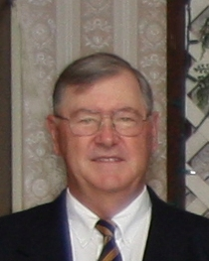Gord Sharpe
Special Events Chair

Membership Report

At the General Meeting on March 16th a motion was
passed to raise the Branch dues to $50.00 for the 2012
Legion year. The reason for this is higher per capita
costs, postage and stationary.

As of this Bullytin our numbers are down about 4% from
this time last year. I would hope those members who are
not paid up yet will get in to the Branch and renew soon..

Our recruiting never stops, if you know someone who shows an interest, please bring them in to see what we have to offer and then get them signed up.

As always if you have any concerns or questions please contact me.

Mike Alkerton - Membership Chair

Special Events Report

On Sunday, 5th June, 2011 we will be having our annual
church parade. All those wishing to take part please fall
in at the Branch at 09:45am.

Everyone is welcome to join the formation as we make
our way to St. James Anglican Church.

We will march off at 10:15am and proceed to St.James
church on Melville Street.

For those who cannot march in the parade, but wish to
attend the church service, it will start at 10:30am and all
are welcome to attend.

Lunch will be available at the Legion after the service.

Gord Sharpe - Special Events Chair
Gord Sharpe
Special Events
Chair

Mike Alkerton
Membership
Chair
Ladies Auxiliary Report

Our final beef on a bun night will be held on Friday
May 27th from 5:30 until 7:30. Come on out and enjoy a
great dinner for $8 and the Legion usually has entertain-
ment as well. These nights will commence again in
September. Our fall beef nights will be held on Friday
September 23rd, Friday October 28th and Friday
November 25th.

We have been doing quite well in the area of sports. We
placed 1st in the Zone Cribbage Tournament and went on
to the District Tournament where we placed 6th and get to go on to Provincials.

We also placed 1st in the District Singles and Doubles Dart Tournament and will be going on to Provincials at the end of April.

To top it all off we placed 1st and 2nd in the Zone Team Dart Tourn-ament and then went on to District where we placed 1st. We will be hosting the Zone Cribbage, Zone Team Dart and District Team Dart tournaments in 2012. Congratulations to all who participated and good luck in the upcoming tournaments.

We visited Ethel Lampman and presented her with her 50 year pin as well as her 55 year bar. The visit went really well and I'd like to thank Gerry Hopkins and Terry Kobylinski in joining me for the presentation. We will also be visiting Ruth Rivers to present her 50 year pin in the near future. I'd like to congratulate the following members for receiving their years of service pins as well: Pauline Whittaker - 35 year pin; Arlene Gross - 30 year pin and Dana Dilabbio -15 year pin.

Our annual draw will be back again in the fall and we are looking forward to having many great prizes up for grabs.

I'd like to take this opportunity to thank all of our members for all of their hard work throughout the LA season. I'd also like to thank the Legion for their continued support.

Yours in Comradeship,
]
Terrie Gubbins - President - Ladies Auxiliary

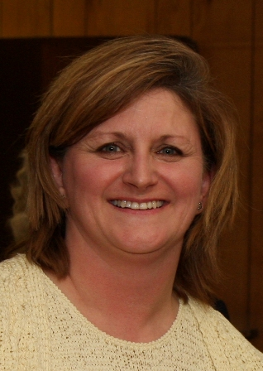Terrie Gubbins
Ladies Auxiliary
President
Sunday - 29th May - Spring Work Party - 9:00am Volunteer some time to help spruce up the Branch for our D-Day Church Parade. Both inside and outside tasks are available - Add your name to the sign-up sheet next to the smoking entrance doorway.
Saturday Meat draws at the Legion

Each Saturday from September through May we hold the
President’s Meat Draws at 3:pm, and year round each
Saturday we hold the Weekly Meat Draws at 4:30pm.

I have attended the Meat Draws and truly enjoy the
friendly atmosphere at the Branch, along with convers-
ation and camaraderie among fellow comrades. I was
even lucky enough to win one of the meat prizes. The
meat prizes are purchased freshly each week at Costco’s.

Branch members always make sure they get to the Branch
on Saturday afternoons around 2:30pm in time for the
President’s Meat Draws, which start at 3pm for the 1st of 6 meat draws.

Tickets for the first three draws are $1 each, and the winner has their choice of the various meat cuts on display. The next ticket costs $2 but it is good for the 4th, 5th and 6th draws.

If you’re busy and can’t get to the Branch on Saturday then the Weekly Meat Draw will give you a chance to win a meat prize every Saturday at 4:30pm.

A box is mounted on the wall to the left side of the bar with envelopes and pencils so you can enter this draw whenever you’re in the Branch. Just put a loonie in an envelope, seal it, write your name on the outside and place it in the box on the wall. At 4:30pm each Saturday, the tickets are removed from the entry box and meat prizes are awarded to 2 lucky recipients. If the winners aren't in the Branch when the draws occur, they are immediately notified by phone of their win and can pick up their prize from the Branch.

Peter Whittaker - Public Relations Chair

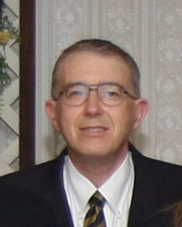Peter Whittaker
3rd Vice President and Public Relations
Chair

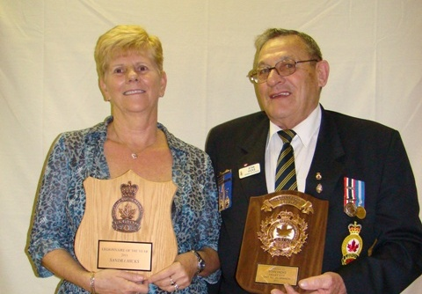
House Report

The long cold winter is over and spring is upon us, and this
year’s Spring Clean Up Party will be held Sunday 29thMay,
2011 starting at 9.00am.

Volunteer some time to help spruce up the Branch in time
for the D-Day Church Parade to be held on the following
Sunday 5th June, 2011.

There will be a sign up sheet posted on the Events Bulletin
board.

Lunch will be provided to all the volunteers. It is only a couple of hours of light work and a great lunch.

Hal Hamilton - House Chair

Hal Hamilton
House Chair
2011 Honours and Awards Recipients
Pictured above are Sandra Hicks who was was named Branch 36’s Legionnaire of the year, and her husband Stan who received the Legion’s Meritorious Service Medal for his dedicated service to the Legion.

Sick Report - Stan Hicks

January - 2011
20 - Ken Slote at General
20 - Randy Kynast at home after surgery on foot
20 - Dawn Lewis at home - wrist compound
22 - visited Randy Kynast at home
31 - Deb Cooley at General - bypass

February - 2011
05 - Deb Cooley at home
08 - Mike Alkerton visited Jack Sullivan at retirement
home - 97 years old - okay
10 - Alex Brown at Juravinski
12 - Alex Brown - not very good
14 - George Kay under the weather - heart
15 - Pat O’Connor at Mac
15 - Dana Dilabbio at St.Joe’s - foot
20 - Dana Dilabbio at home
23 - Marg Payner at General - no visitors
25 - Joan Alkerton at General - bypass

March - 2011
02 - Marg Payner at home
03 - Joan Alkerton at home
03 - Pat O’Connor at home
03 - Roy Gunn at hospital
04 - Roy Gunn at home - broken ribs
12 - Alex Brown moved to Bob Kemp hospice

April – 2011
06 - G.G. Livingston – heart
07 - Suzi Mellon - day surgery- at home
09 - Suzi Mellon - still sore 09 - Pat O’Connor at St.Peters

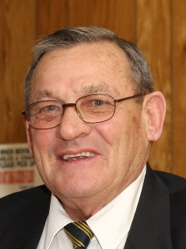
Stan Hicks
Sick / Last Post
Chair

ffffff
Last Post

Art Chambers - January 21st, 2011
Ken Slote - January 29th, 2011
Art Denardis - February 24th, 2011
Marilyn Scott - March 9th, 2011

We Will Remember Them

Honours and Awards Report

Deviate: to turn aside or diverge from a course of action.
Well that was the flavour of the evening. Our Honours
and Awards and Ladies Auxiliary Awards Banquet was
"fandabbydozie" (Hi Mum!).

A great time was had by all. Many deserving members
received Certificates of Merit or Appreciation and many
received Years of Service Pins. Please take a moment
to check out the photos on our Branch website (link to:
http://br36dundas.org/awards2011/awards2011.html).

Congratulations to Sandra Hicks as our Legionnaire of the Year, and to Stan Hicks, who received the Legions Meritorious Service Medal. They
are our own "Royal Couple" at the Branch for the next year!

Thank you to everyone who helped make the event a success.

John Murphy for Suzi Mellen - Honours & Awards Chair

Branch Elections - Come on out and VOTE - It’s your duty!

The Legion is a democratic organization and each year we have an election to vote for the executive to run our Branch. Our election is at 8pm on Wednesday, 4th May, 2011. Any Branch 36 Legion member
is eligible to run for any position, and all Branch 36 Legion members can vote in the election. If you are interested in helping to run the Branch, or you want to vote for someone in a position on the executive come on out and vote.

Only with the participation of the membership can the Legion stay healthy. You may not be able to get to the Branch on election night, but it doesn’t mean you can’t take part. Let John Murphy the current Branch President know about your interest to take part, and I am sure he will present it at the election.

You may not wish to be on the Executive, but there are lots of appointed positions for those wishing to take part in running the Branch, so you may not want to run for President, but you can still take part - come on out and let the current executive know of your interest.

Peter Whittaker – 3rd Vice President and Public Relations Officer

House Report

Picture description here

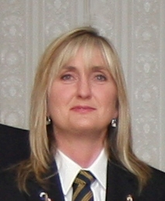
Suzi Mellen
Honours and Awards
Chair

Youth Education Report

Again this year, we are very proud to announce that a
number of Valley City Branch 36 students, who won
recognition in the November Remembrance Day poster,
poetry and essay contests have won further recognition
at the Zone level in Burlington.

Just after Remembrance Day, we sifted through
approximately 100 entries, and submittted the winners’
work to Zone. One student from Dundas Valley City
Branch 36 earned a silver medal at Zone:

Stephanie Nevan - Intermediate Poetry

In addition, 3 Valley City students have placed first at Zone. This is an excellent result in our third year of competition entries. We had one winner in 2008, and one in 2009 advance through Zone to the Provincial level of competition, and this year Valley City has three! (First Hockeyville, and now this! Where will it end?)
These 3 students are:

Kaitlyn Den Dekker (Senior Essay)
Michele Lobbezoo (Senior Poetry)
Sidney Kennelly (Senior Poster / Black & White),

It’s interesting that some of these students (or their siblings) have won recognition in past year’s competitions, so it appears that this is very good experience for today’s students, tomorrow’s citizens.

Special thanks are due to two Valley City members who originally helped to evaluate all the entries in November: Tony Bratchitsch from Valley Town Toastmasters, who obviously helped choose some outstanding local district winners, as a number of them have advanced to the Provincial level of competition.

Sincere thanks to Branch 36 Valley City Legion for their financial support of Youth Education, and particularly to Comrade Mike Alkerton for his continuing moral support of Youth Education through this Branch.

Lorne Evans - Youth Education Chair
Lorne Evans
Youth Education
Chair

Brain cells come and brain cells go, but fat cells live forever.

Canteen Report

The Canteen will soon be on summer hours and that
means that we will not be open on Sunday's except for
the Family Bbq's.

We will also be closing the bar at 6pm on Saturday's if
there is not a function booked in the Wentworth Room
or the Banquet Hall. We will continue to take bookings
for both of these rooms so if you want to have a birthday,
anniversary or any other type of party the rooms are still available and we will remain open to allow you to enjoy your Branch.

This decision was made because we understand that people would much rather be outside enjoying the weather (and a drink) rather than sitting inside. Remember, you can still book the front room or the banquet hall on Saturday nights and you will be accommodated on a first come first served basis.

Dawn Lewis - Chair Canteen and 1st Vice President

Poppy Fund Report

To everyone who donated to our Poppy Fund campaign
I extend a hearty and grateful THANK YOU.

Cherie Harrington, Poppy Fund Treasurer, and I would
like to thank all those who volunteered a couple of hours
to collect donations for the Poppy Fund. Without the help
of you, the volunteers, we wouldn’t have a successful
Poppy Fund campaign.

Volunteers taking part reported an interest by all those donating to the Poppy Fund, maybe because they see more of our armed forces on television, and so are more aware of all veterans. All age groups in the community are glad to donate to the Poppy Fund and it is sad that we still don’t get enough volunteers to man all of the collection posts all of the time. If we have more volunteers we will collect more donations.

Please think seriously about taking part in our next Poppy Fund campaign. All you will need is a couple of hours, so please sign up when you see posters appear in the branch. Thank you again.

Gerry Belec
Poppy Fund
Chair
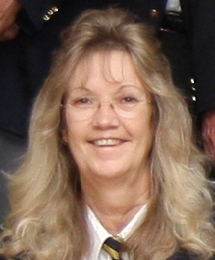Dawn Lewis Canteen Chair

Sports Report

On January 29th, Valley City Dundas Branch 36 hosted
Singles and Doubles, Zone Darts. We had a successful
turnout, and we would like to thank everyone who helped
out. Barry Peer and Eamon Morgan qualified for District,
but unfortunately Eamon Morgan could not continue play
so Jim Kielty filled in for him.

On January 30th, team Zone Darts was hosted by
Battlefield Stoney Creek Branch 622.

On March 26th, Mount Hamilton Branch 163 hosted Zone Euchre. Brenda Glass, Elmer Cantello, Gerry Belec and Gerry
Reigheld qualified for District, which will be hosted by
Port Colborne Branch 56 on 16th April.

On April 23rd, Battlefield Stoney Creek Branch 622 is
hosting mixed Zone Darts for Doubles and Teams.

On April 30th, Valley City Dundas Branch 36 is hosting
District Youth Darts.

There are still some sports events to take place and sign-up sheets for them are on the board. Take a look and sign up.

Jordan Deneau and Brody Howlett - Sports Co-Chairs

Dundas Model Train Display at the Legion - Gord Sharpe
On Friday, May 13th, during the Legion Fish Fry, the Dundas Modular Railway Club, which is based at the Dundas Legion Branch 36, will have their model train display in operation in the upstairs Banquet hall.
Anyone attending the Fish Fry is welcome to come upstairs to view the display which will be open to the public from 4:00pm until 9:00pm on Friday evening May 13th.
Don't miss out on this opportunity to see the newest activity at the Legion in action. Admission is FREE to all.

There is always death and taxes; however, death doesn't get worse every year.

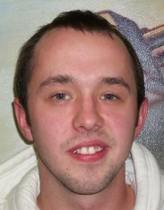Jordan Deneau
&
Brody Howlett
Sports
Co-Chairs


Services
Chimney Cleaning & Liners
Smoking Problems Cured
Rain & Animal Covers
Animals & Nests removed
905-628-0227
Dundas

Branch 36 - Upcoming Events
April 2011
Wednesday - 27th April - Ladies Snooker Banquet Schwaben Inn
Friday - 29th April - Beef on a Bun - 5:30-7:30pm
Friday - 29th April - Entertainment - 7-10pm music from Dave Burden
Saturday - 30th April - Legion District Youth Darts Tournament Registration - 08:30am Play at 09:00am

May 2011
Wednesday - 4th May - Branch Election - 8pm Elect your Executive
Thursday - 5th May - Ladies Darts Annual Meeting - 6pm Wentworth Room
Thursday - 5th May - Ladies Darts Banquet - 7pm Wentworth Room
Saturday - 7th May - Sunday Fun Darts Banquet - 6pm Wentworth Room
Friday - 13th May - Fish Fry - 4:30-7:00pm
Friday - 13th May - Friday - Open Microphone Night - 7-9pm
Monday - 23rd May - VICTORIA DAY - CLOSED
Friday - 27th May - Beef on a Bun - 5:30-7:30pm
Friday - 27th May - Entertainment - 7-10pm music from Dave Burden
Sunday - 29t^{h} May - Semi-Annual Spring Work Party – 9:00am

June 2011
Weekly Meat Draw - Every Saturday - 4:30pm
Sunday - 5th June – D-Day Church Parade – 09:30am
Friday - 10th June - Fish Fry - 4:30-7:00pm
Sunday - 19th June – Family Barbeque – 4-6pm

July 2011
Weekly Meat Draw - Every Saturday - 4:30pm
Friday – 1st July - CANADA DAY - Bar 12 noon-5pm and
Good Neigbour BBQ from 2pm to 5pm
Friday - 8th July - Fish Fry - 4:30-7:00pm
Sunday – 17th July – Family Barbeque – 4-6pm

August 2011
Monday – 1st August – CIVIC HOLIDAY - CLOSED
Friday - 12th August - Fish Fry - 4:30-7:00pm
Sunday - 21st August - Family Barbeque - 4-6pm

September 2011
Monday – 5th September - LABOUR DAY - CLOSED
Wednesday - 7t^{h} September - Youth Darts Registration - 6:30pm
Thursday - 8th September - Lady’s Darts Registration - 7pm
Thursday - 8th September – Men’s Darts Registration - 7pm
Friday - 9th September - Fish Fry - 4:30-7:00pm
Sunday - 18th September - Family Barbeque - 4-6pm
Friday - 23rd September - Beef on a Bun - 5:30-7:30pm

