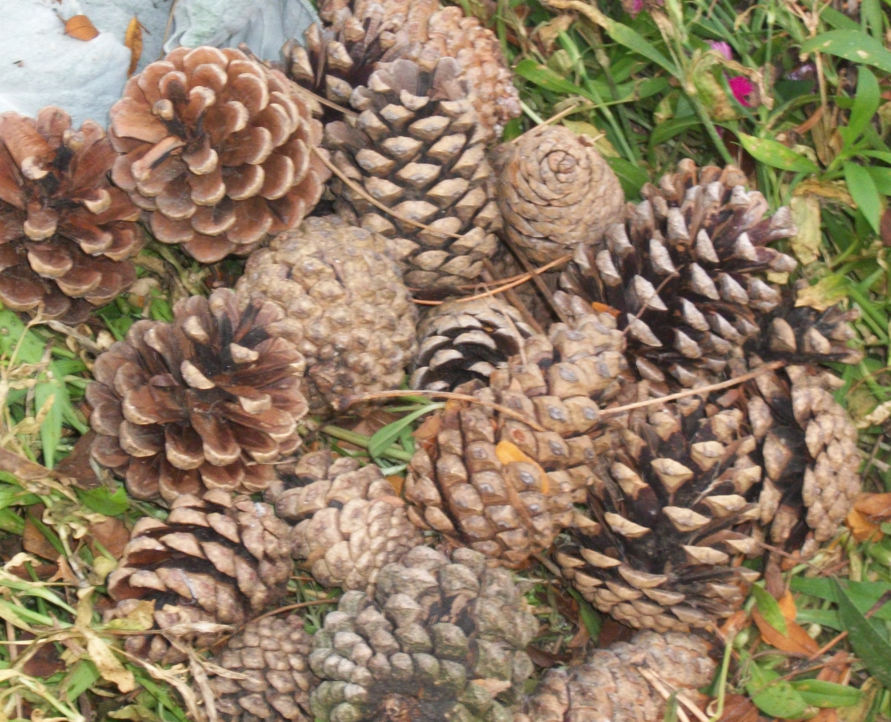
The Bullytin
Valley City Branch 36
The Royal Canadian Legion
December – 2010
Phone: (905) 627-7221 Email: rclbr36@cogeco.net
http: //www.br36dundas.org
Picturesque as it may be, the above was only a small part of what was raked up and hauled away by our work party who cleaned up the Branch for Remembrance Day.


President’s Report

It was my honour to represent the Branch at our
Remembrance Day ceremonies.

All three service branches (Army, Navy, Airforce)
were well represented along with members of the
Hamilton Wentworth 11th Battery and our own
Veterans and Branch members. Our Branch padre, Archdeacon Jim Sandilands, provided spiritual guidance and words of remembrance.

A heartfelt "Thank You" to Comrades Gerry Belec and Cheri Harrington who were outstanding in their role as Poppy Campaign Co-chairs. Their Poppy Committee was tireless in its efforts. Thanks to all the Poppy Volunteers and thanks to those who supplied food for them. As Legion members we must remember that when we took our Legion oath we comm-itted to help with the Poppy Campaign. What’s a couple of hours distributing Poppies or making an extra pot of stew? Remember, there are always many ways to help.

Much gratitude goes to all those who helped feed the Veterans, their families, Branch members and cadets who returned to the Branch after the ceremony.

On December 15th we have a special General Meeting at the Branch to approve new Branch by-laws. All members are invited.

Please welcome Jordan Deneau and Brody Howlett
as your new Sports Chairmen. They are enthus-
iastic, welcome additions to our Executive.

John Murphy
President

Our Annual Veteran's Christmas Dinner is on December 8th. We have a choral group and Highland Dancers for entertainment.

On January 22, 2011 we will have our annual Robbie Burns Dinner. Tickets will be available in the New Year and many reservations have already been submitted. Come join us for a great evening.

Wishing Season's Greetings and a Happy New Year to all.

John Murphy – President

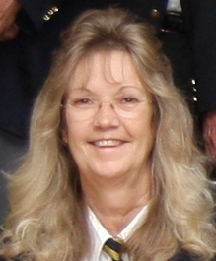
Dawn Lewis
Ways & Means Chair

Ways & Means Report

First of all, I would like to thank Sandra and
Stan Hicks for the wonderful job they did at the
October fish fry. We were short staffed and all
it took was one phone call and we were right
back on track. They did an absolutely wonder-
ful job and we would not have been able to pull
it off without them. Thank you both so much.

I'd also like to remind you to put your loonie in an envelope for the Saturday 4:30 meat draw. Put your name on it, and your phone number if you can't be there, and drop it in the box by the entrance to the washrooms. You still have two chances to win a great cut of meat for a dollar.

The Sports Turkey Roll is on Friday December 3rd, at 8pm. Tickets are available at the bar or from a
number of Branch members. They are $5.00
each and are good for 40 chances to win.
You don't have to be there to win. This
Turkey Roll sells out fast so be sure to get

Public Relations Report

In June we entered the Branch 36 Bullytin in
the Royal Canadian Legion’s Bulletin comp-
etiton. Jim Whitfield, our Legion Zone
Commander recently presented us with a
plaque and told me the Branch 36 Bullytin
won the Bulletin competition at the District
level. The plaque has been mounted in the Branch
so all may see it. It is only with the help of Branch 36 members that the Bullytin is what it is today. With
your help and suggestions we can improve it and
win the provincial level next year.

Peter Whittaker
Public Relations
Chair

your tickets early. The Ladies Auxiliary. are also having their Christmas Penny Sale draws for some pretty great prizes on the same night, so the place will be really busy. Come early to get a seat.

The Fish Fry's continue throughout the year on the second Friday of each month. Don't forget to bring everyone that you know for the best Fish 'n Chips (or Chicken) in the entire area. If you would like to volunteer to help out with the Fish Fry's, see me at the Branch or leave a note for me with the bar steward. Many hands make light work, and each month thanks to you and your word of mouth the Fish Fry's keep getting bigger and better. We have a very dedicated group of volunteers that makes this happen and I don't think that I can say 'Thanks' enough. It may be a lot of work but we also have a lot of laughs while we're at it and it just seems to make the effort worthwhile. Thanks again to everyone involved, and thanks to all of you for making this such a success. We really appreciate your support.

Dawn Lewis - 1st Vice President and Ways & Means Chair


Colour Party Report
The Colour Party took part in the Remembrance Day parade with our own Bill Armstrong lead- ing the parade with our National Colours. Two members of the Colour Party were absent due to illness or vacation. Cadets from all three bran- ches of the service stepped in to help out the parade as well as “Artillery George”. Without their support the Colour Party would have been much smaller and not so nearly as impressive. I’m hoping to get a copy of the Cable 14 showing of our parade on CD for anyone who would like to borrow it.
Our next appearance will be at the ‘General Meeting’ taking place on December 15th. As always we have open- ings in the Colour Party for new members. If inter- ested please contact me at 905-578-2758.
James Byron - Colour Party Commander

Canteen Report

Things have been going well and its great to see
so many people back out on a regular basis. It
would also be really nice to see a few more faces
enjoying the many talents of the people at
the 'Open Mike' on the Friday night after the Fish
Fry or Beef on a Bun meals.

If you have any other ideas to put bums in the seats
during the evenings, please let us know. We're
open to suggestions.

Dawn Lewis - Canteen Chair

Dawn Lewis
Canteen Chair
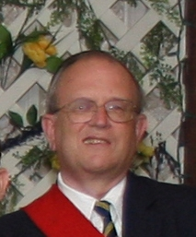
James Byron
Colour Party
Commander &
Sergeant-at-Arms

Membership Report

“Early Bird” is doing well. As of this printing
50% of our members renewed!!

NOW! The other 50% I would urge you to
drop by the branch or mail in your dues.
Remember dues are still $45.00. Recruiting is
going well, but the more the merrier.

“Just Bring One”

Any questions or concerns please contact me.

P.S. To represent the branch at any Legion
functions you must be initiated.

Mike Alkerton - Membership Chair

Mike Alkerton

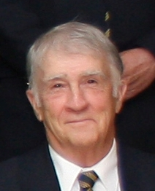
Mike Alkerton
Membership
Chair

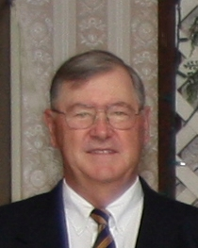Gord Sharpe
Special Events Chair



Identify your fellow Legion Member

Do you recognize the Branch 36 veteran pictured above.
Turn to page 15 to see if you are correct.
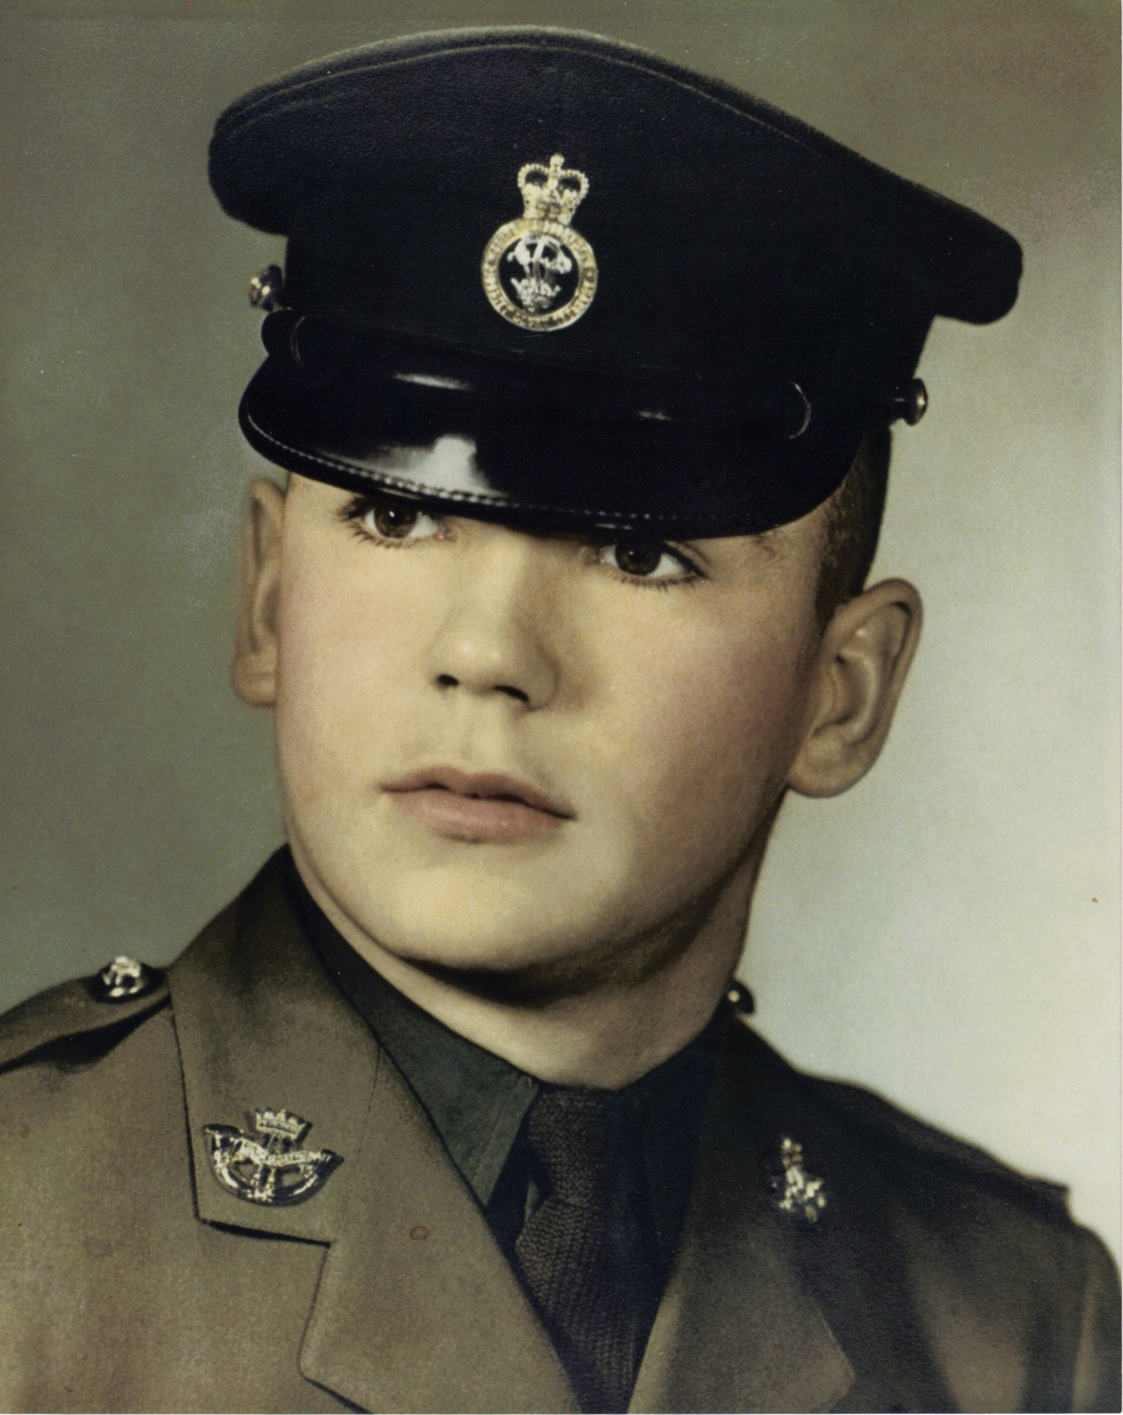

Gerry Belec
Poppy Fund
Chair

fdfdfdff

Poppy Fund Report
First thanks to my co chair Cheri Harrington for her help this year, and all of the people who were out campaigning. With all the weather we had - no rain or snow, it was a very good year.
Special thanks to Mike Alkerton, Jim Kielty, Mal Horner, Roy Laufman, Stan Hicks and Al Boyle for the fine jobs they did, and to all those who helped separate and roll the coins.
Thanks to Leo Daigle for the use of his coin counting machine from the Pioneer Gas bar. It sure saved a lot of time wrapping coins.
Now for the good news - this was one of the best years we ever had.
Gerry Belec – Poppy Fund Chair

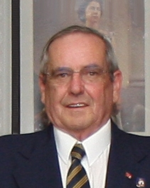
Gerry Belec
Poppy Fund
Chair



Bursaries Report

Bursaries are available for children and grandchildren of Ordinary members. Some changes have been made. Please see me.

Mike Alkerton - Past President and Membership Chair

*ATTENTION* – Branch is CLOSED - December 25th, December 26th, December 27th and December 28th

Turkey Roll News: The Sports Turkey Roll is on Friday,
3rd December, 2010. Get your tickets early, as all tickets sold out for the last Turkey Roll before the event.
Branch 36 - Upcoming Events

December – 2010
Friday – 3rd - Sports Turkey Roll, Ladies Auxiliary 3rd Annual Penny Sale Draw - 8pm
Wednesday - 8th -Veteran's dinner - bar opens 5:30pm - sit down to dinner - 6pm
Friday - 10th - Fish Fry - 4:30-7:00pm
Friday - 10th - Open Microphone Night - 7:00-9:00pm
Wednesday - 15th - GENERAL MEETING - 8pm - All members are welcome to come and vote on Branch Bylaws
Friday - 24th - Christmas Eve Day - Noon-5pm Choir Singing Competition
NOTE: Branch CLOSED Saturday 25th, Sunday 26th, Monday 27th, Tuesday 28th
Friday - 31st - 8pm - New Year's Eve Pot Luck Party
Welcome in the New Year 2011 with us

January – 2011
Friday - 14th - Fish Fry - 4:30-7:00pm
Friday - 14th - Open Microphone Night - 7:00-9:00pm
Saturday - 22nd - Robbie Burns Supper - 5:30pm Bar, 6:30pm Dinner & Entertainment
Friday - 28th - Beef on a Bun - 5:30pm-7:30pm
Friday - 28th - Entertainment - Mike Woods - 7:00-11:00pm
Saturday - 29th - Tony Lambert Snooker Tournament-10-6pm
Sunday - 30th - Tony Lambert Snooker Tournament - 10-4pm

February – 2011
Friday - 11th - Fish Fry - 4:30-7:00pm
Friday - 11th - Open Microphone Night - 7:00-9:00pm
Friday - 25th - Beef on a Bun - 5:30pm-7:30pm
Friday - 25th - Entertainment - Dave Burden - 7:00-10:00pm


Ladies Auxiliary Report

The Ladies Auxiliary draw is currently underway
and going very well. The final draw date is on
Friday December 3rd and coincides with the
Legion Turkey Roll. Come on in and check out
the prizes. You get 25 tickets for just $5 and you
get to choose which prize(s) you want to put your
tickets into.

I would like to take this opportunity to thank
Dana Dilabbio for all of her hard work and dedication. We wish everybody good luck and we want to thank you for making this draw a wonderful success.

Our next Beef on a Bun will be on Friday November 26th
from 4:30 to 7:30. There will NO Beef on a Bun held in December but we will be back again in January. The first
three 2011 dates are as follows: January 28th, February 25th and March 25th.

Thanks to all who attend our functions for your ongoing support.

The Ladies Auxiliary District Singles and Doubles Dart Tournament is being held at Branch 163. Good luck to all
our ladies who qualified.

Working as a team helps us reach our goals. If we don't work together it effects us all.

Yours in Comradeship,

Terrie Gubbins - President - Ladies Auxiliary

Terrie Gubbins
President
Ladies Auxiliary


Sick Report - Stan Hicks

October - 2010

15 - Ken Slote at Mac
15 - Gerry Pack at General
15 - Ian Taylor in & out of hospital
15 - Paul Penney in & out of hospital
20 - Brent Anderson in & out of hospital - stint
21 - Gerry Pack at home - out & about
22 - John Toomey at St.Joe’s
22 - Wes Brindle moved to St.Joe’ Villa
22 - Ian Taylor - out & about
27 - Visited John Toomey at St.Joes - having test

November - 2010

05 - Ron Wilson at Mac & General - heart stint
09 - Harol Farmer at Idlewyld Nursing Home
10 - Ron Wilson at home
11 - Bill Terry at General
12 - Bill Terry at General ICU - stroke
18 - Kenny Slote at Mac

Stan Hicks
Sick & Last Post Chair

Last Post

Marion Donald – October 26th, 2010
Bill Terry – November 13th, 2010

We Will Remember Them

Serving Members Take Salute at Remembrance Day

Banquet Hall Report
We still have a few spaces in the Banquet Hall or Lounge for parties this holiday season. Please call to book.
A reminder: you may not bring anything to drink into the lounge when you book it - this includes non alcoholic beverages as well.

Butch O’Neill, Murray Floyd and Stan Rankine get ready to take part in the Remembrance Day Parade.

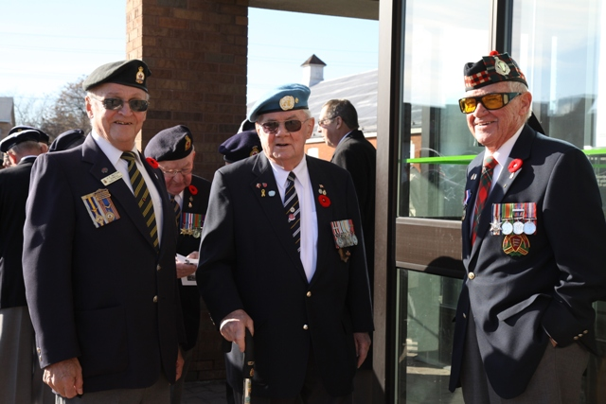

Old Friends Remembered
Attention Comrades: Every year we collect CANNED GOODS for needy families, and this year is no different. There are people in the community that we can help by donating food at this festive time of year when we are giving thanks for what we ourselves enjoy. Donations can be brought to the Branch until December 20th.
Thank you for your support !!!

Special Events Report

I wish to thank all those who participated in this
year's Remembrance Day parade and service. I
would also like to thank all who assisted me in
the preparations and routines of the day.

I hope that everyone enjoyed the day.

We will see you all next year!

Gord Sharpe - Special Events Chair

Gord Sharpe
Special Events Chair



Honours and Awards Report

The 2011 Honours & Awards Banquet will be
held on Saturday, March 5, 2011. Mark your
calendar for this exceptional evening!

Calls will be made to those eligible for years of
service pins. These calls will commence in early
February. If you think you are eligible for a pin
and have not received a call by February 15th, please call the Branch. Tickets for the evening, including a full roast beef dinner and are only $20.00 per person. Tickets will be available on February 1, 2011. We have sold out in the past two years so get your tickets early.

We need your suggestions for Legionnaire of the Year (including rights to the remote) and also Certificates of Appreciation and Merit. Please leave a note in the
suggestion box or speak with me.
John Murphy for Suzi Mellen - H & A Chair

Suzi Mellen

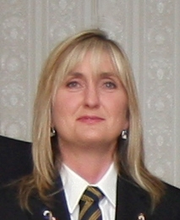
Suzi Mellen
Honours and Awards
Chair


Youth Education: Remembrance

The Dundas Valley Branch 36 Youth Education
Committee is very pleased to announce the
completion of our recent 3rd Remembrance
competition. Approximately 100 posters, essays,
and poems were submitted by various local and
area elementary and secondary schools, and
colleges. Special thanks are due to Tony
Bratschitsch and Richard Parrish of Valley
Town Toastmasters, and Mike Alkerton, who helped with the organizing and judging of a large number of submissions. Winners are as follows:

Junior Poster (black and white): 1st - Esther Kranendonk,
2nd Julia Byl, 3rd - Joel Naves Junior Posters (colour): 1st - David Elgersma, 2nd - Henriette Koonstra, 3rd - Gerrit Vandenberg Senior Posters (black and white): 1st- Sydney Kennelly, 2nd - Michelle Audet, 3rd - Anna Hirst and Chelsea Vandermaart Senior Posters (colour): 1st - Angelica Zelenovich, 2nd - Olivia Vandenberg, 3rd - Evelyn Boekestein and Alexis Vase Intermediate Poetry:
1st - Stephanie Neven, 2nd - Vanessa Wursten, 3rd - Talaya Koppelaar Senior Poetry: 1st - Michelle Lobbezoo,
2nd - Amber Vlietstra, 3rd - Stephanie Elgersma
Intermediate Essays: 1st - Justine Van Dyk
Senior Essays: 1st - Kaitlin Dendekker, 2nd - Ian Jonkman, 3rd - Jiang Hao Jun and Alisha Jonkman

We wish to commend the teachers, students, and parents who continue to participate in this important aspect of
Canadian citizenship.

Lorne Evans - Youth Education Chair

Lorne Evans
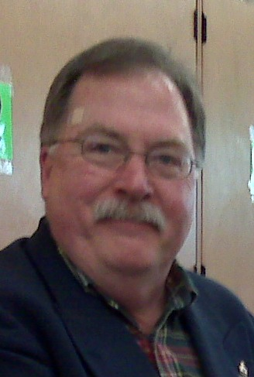
Lorne Evans
Youth Education
Chair


Sports Report

Sign-up sheets for various Legion sporting
activities are posted on the wall next to the
smoking tent door. Why not sign up for one?

They are lots of fun, you get to represent the
Branch and will often get you out of town to a
town you’ve always wanted to visit. Who knows,
you might even bring back a trophy.

The sports you can choose from
vary greatly. Sign up, represent the
Branch and have some fun.

Jordan Deneau
&

Brody Howlett
Sports
Co-Chairs

Entertainment Report

Friday - 24th December - 12-5pm Choir Singing
Friday - 31st - 8pm - New Year's Eve Party
Saturday - 22nd January - Robbie Burns Supper
Friday - 28th January - Mike Woods
Friday - 25th February - Dave Burden

Eamon Morgan - Entertainment Chair

Eamon
Morgan
Entertainment
Chair

President’s and Weekly Meat Draws

The President’s and Weekly Meat Draws occur every Saturday from 3 to 4:30pm. If you’re looking to relax on a Saturday afternoon why not drop by the Branch and win a meat prize while you’re here. A total of 8 draws take place and everyone has a good time.

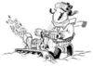
House Report

I would like to thank all the members who gave up
time to the work party on November 07, 2010.
Your time and commitment is greatly appreciated.
I also would like to thank Peter Martin for his time
and preperation of the lunch meal that was served.

A Branch 36 Thank You to the following: Mike
Alkerton, John and Maryann Blair, Donny Brooks, Terry
Calder, Jordan Deneau, Lorrie Deneau, Murray Floyd, Sandra and Stan Hicks, Geof Hodgson, Brody Howett, Kathy Howett, Marlyn Latchford, Roy Laufman, Peter Martin, Len Owen,
Jack Murnaghan, John Murphy, Larry O'Connor, Paul Penny, Brian Poole, Darren and Liam Rust, Leo
Shaidle, Jim Sherring and Peter Whittaker.

Hal Hamilton
House Chair

Identify the Legion member – Answer

If you guessed Paul Penney you were right. Paul was a
paratrooper in Germany with the 2nd Princess Patricia’s Canadian Light Infantry from 1962 to 1965.
,
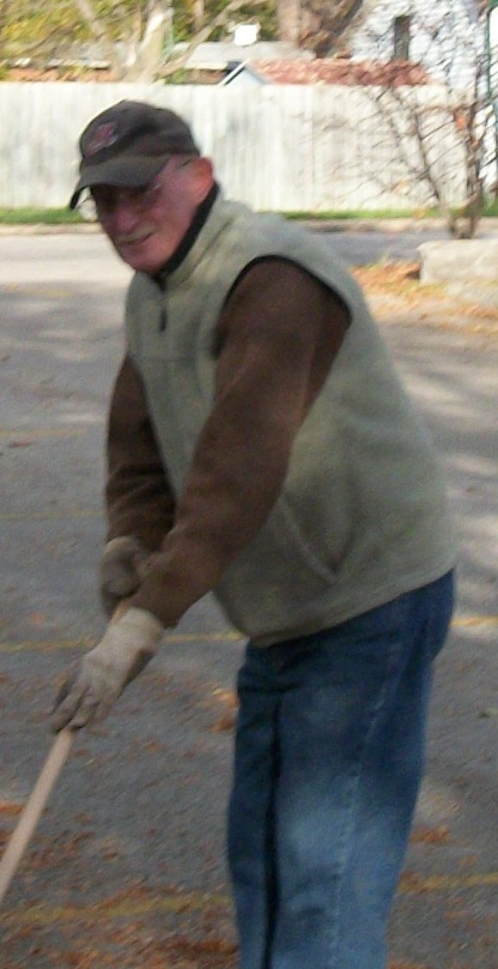
Volunteers at Work

John Blair and Jim Sherring work on raking up leaves.

